**REQUEST FOR PROPOSALS**

**City of Gardiner**

**Downtown Master Plan- Reinforcing the City’s Connection to Nature**

The City of Gardiner (hereinafter “City”) seeks a qualified professional Consultant or Consultant Team (hereinafter “Consultant”) to assist the City in developing a ten-year Master Plan for Gardiner’s historic downtown, as described, in large part, by the Department of Agriculture, Conservation, and Forestry’s Coastal Community Grant program.

This grant program is designed to address the following priority goals: ensuring sustainable and vibrant coastal communities, improving coastal public access, addressing effects of land use activity on water quality, restoring coastal habitats, and preparing for coastal storms, erosion, flooding, and coastal hazards.

The Downtown Master Plan will provide the roadmap for implementing the community’s vision

for the future of the historic downtown while addressing the grant program’s priority goals.

**Project Summary**

Much like Hallowell and Augusta to the north and Richmond and Bath to the south, Gardiner is defined by its ties to the Kennebec River. More than just a natural landmark, the Kennebec River provided transportation and sustenance to Maine’s native people. The natural bounty of the Kennebec River, and its tributary, Cobbosseecontee Stream, drew early European settlers to the area as well. Looking to exploit the power of the local waterways, Dr. Silvester Gardiner, of Boston, secured the land that would eventually take his name, and began erecting mills and other manufacturing stores in the mid 1700’s. Gardiner experienced great prosperity and would remain a thriving community for two-hundred years.

However, as the 1960’s came to an end, most of Gardiner’s mills, faced with declining revenues, were forced to close. As the mills closed, residents of Gardiner fled, sending the city into a prolonged period of relative decline. The mills closed in the 1990s – Gardiner Paper Board, Carleton Woolen Mill, HealthTex – the shoe factories closed in the 1960s, but Gardiner kept several big mills into the 1990s

Gardiner today, like many towns and cities across the country, is reversing that trend. The city’s downtown is experiencing a revitalization. Long vacant buildings are finding new life as apartments, condominiums, yoga studios, breweries, restaurants, and other small, local businesses. The 150-year-old Johnson Hall, in the heart of downtown, is currently undergoing a massive 400 seat performance center renovation campaign. The Maine Department of Transportation (DOT) is in the middle of the Gardiner Comprehensive Transportation Improvement Project, which will extend the 6.5-mile Kennebec River Rail Trail south and into downtown Gardiner by way of a new non-motorized multi-use trail over Cobbosseecontee Stream. Further DOT improvements include a lighted riverfront trail along Cobbosseecontee Stream, a pedestrian bridge, replacement of two 100-year old motor vehicle bridges.

The Kennebec River, and its tributaries, are the very reason communities, like Gardiner, sprouted up in central Maine. These resources are playing a large role in Gardiner’s current phase of revitalization. However, due to outdated plans and ever-evolving hazards, the Kennebec River could also play a large role in Gardiner’s potential downfall. Much of the City’s developed area is within the flood plain or in close proximity to the flood plain of the Kennebec River. Chronic flooding and erosion damage to property and roads are becoming more frequent. Increased frequency of high intensity storm events has added to the potential for devastating consequences.

Gardiner needs to develop a downtown master plan that addresses these hazards, threats, and vulnerabilities, while simultaneously constructing a blueprint for sustainable development that builds upon the city’s strengths.

Through this project the City aims to:

1. Equity engage the community, including new and underrepresented voices, in a discussion about the downtown and the places, characteristics and customs that make Gardiner unique.

2. Create a ten-year Downtown Master Plan that puts the City’s natural resources at the center of future planning and development.

3. Develop a process for ensuring the implementation of the plan, tracking whether the City is successful at protecting and enhancing its Downtown and continuing to engage the community in future decision making; and

**Project Objectives**

The overall goal of this project is to develop a Downtown Master Plan for the City of Gardiner.

The Downtown Master Plan will be used to guide new investment in Gardiner’s Downtown, define the direction of revitalization and reuse efforts, and strengthen the City’s connection to the natural environment through green design guidance, low impact development strategies, as well as increasing multi-modal transportation networks and access to active and passive outdoor recreation facilities.

More specifically, the City seeks a Downtown Master Plan that will:

1. Incorporate community members’ vision of the future of Downtown. This should draw on public input gathered through past planning efforts and new efforts through this Master Planning process.

2. Draw on, and integrate, complementary City planning initiatives.

3. Build on the past recommendations of planning efforts that address issues like accessibility, streetscape, and other visual enhancements.

4. Provide the City with a flexible, resilient redevelopment plan that will enable the City to respond to unique opportunities and problems that cannot be predicted, but can be expected, over time.

5. Preserve and enhance downtown attributes such as open space and historic buildings or those specifically identified through the planning process.

6. Develop specific implementation strategies that will support and encourage public and private redevelopment.

7. Recommend strategies for continuing public input and involvement in future development and planning projects; and

8. Develop a final document, including maps and designs, of a quality that will promote the vision and priorities of the community, the City, and the Coastal Community Grant program.

**Past Planning Efforts of Note:**

• **City of Gardiner Comprehensive Plan- 2014**

https://www.gardinermaine.com/comprehensive-plan-review-implementation-committee/pages/comprehensive-plan-and-amendments-2014

• **Cobbossee Corridor Master Plan- 2005**

https://www.gardinermaine.com/economic-development/pages/cobbossee-corridor-master-plan

• **Cobbossee Corridor Bike/Ped Trail Design Report- 2009**

https://www.gardinermaine.com/economic-development/pages/cobbossee-corridor-master-plan

• **Downtown Upper Floor Access Improvement Project- 2002**

https://www.gardinermaine.com/sites/g/files/vyhlif611/f/uploads/accessegress.pdf

• **Gardiner Stormwater Assessment Project- 2017**

https://www.gardinermaine.com/sites/g/files/vyhlif611/f/uploads/stormwaterpresentation-1.17.18councilmeeting.pdf

• **The City of Gardiner’s Downtown Revitalization Plan- 1999**

https://www.gardinermaine.com/sites/g/files/vyhlif611/f/uploads/downtownplan.pdf

* **Orton Foundation Heart & Soul – 2012-2014**
* **Gardiner Main Street designated as a nationally accredited Main Street organization – 2003**

https://www.gardinermainstreet.org/program

**Project Geography**

The Downtown Master Plan will focus on Gardiner’s historical downtown area, mainly represented by the City’s Traditional Downtown (TD) zone and portions of the Intown Commercial (IT) zone.

The Gardiner Historic District lies along both sides of Water Street and is comprised of 46 architecturally significant primarily commercial buildings dating mostly from the 19th century. While a number of the buildings have suffered from cosmetic facade remodeling, the basic fabric remains underneath in most cases and a move toward rehabilitation is well underway.

All major styles of the period are represented and for the most part the scale, proportion and materials of construction of the buildings are compatible. Typical of a once thriving river port, the structures on one side of the street back up either on the Kennebec River or its tributary, Cobbosseecontee Stream. Four structures in the district are considered to be non-contributing intrusions. (also include historic district boundary map)

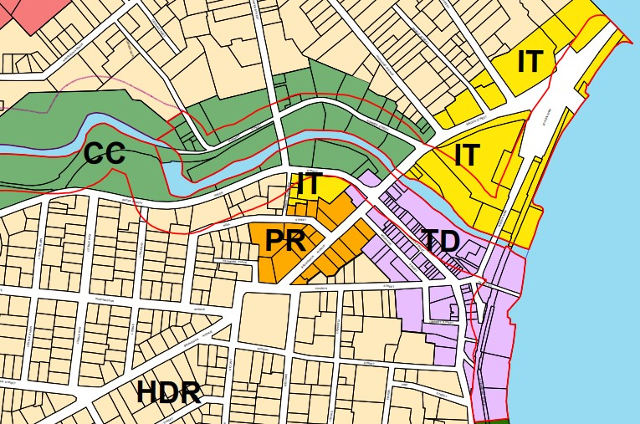

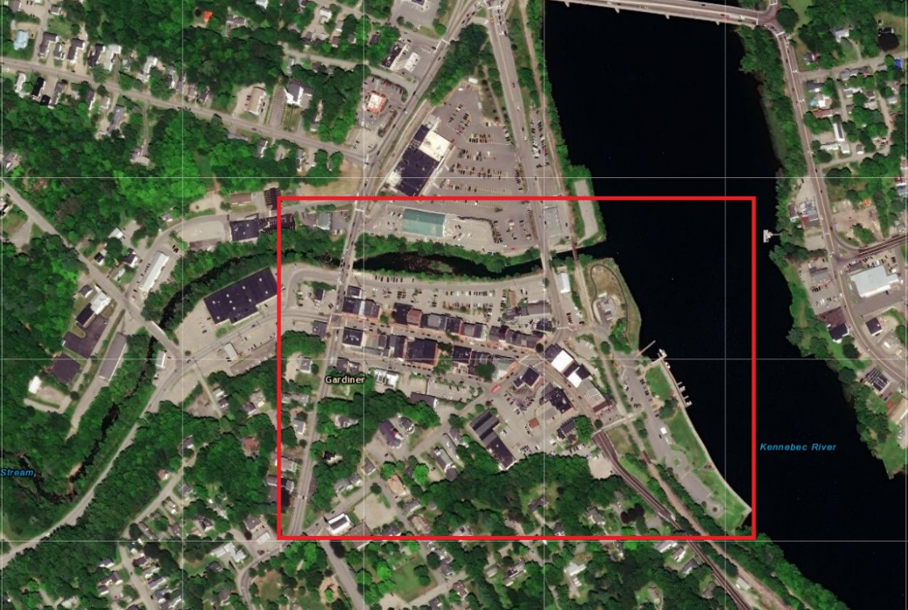

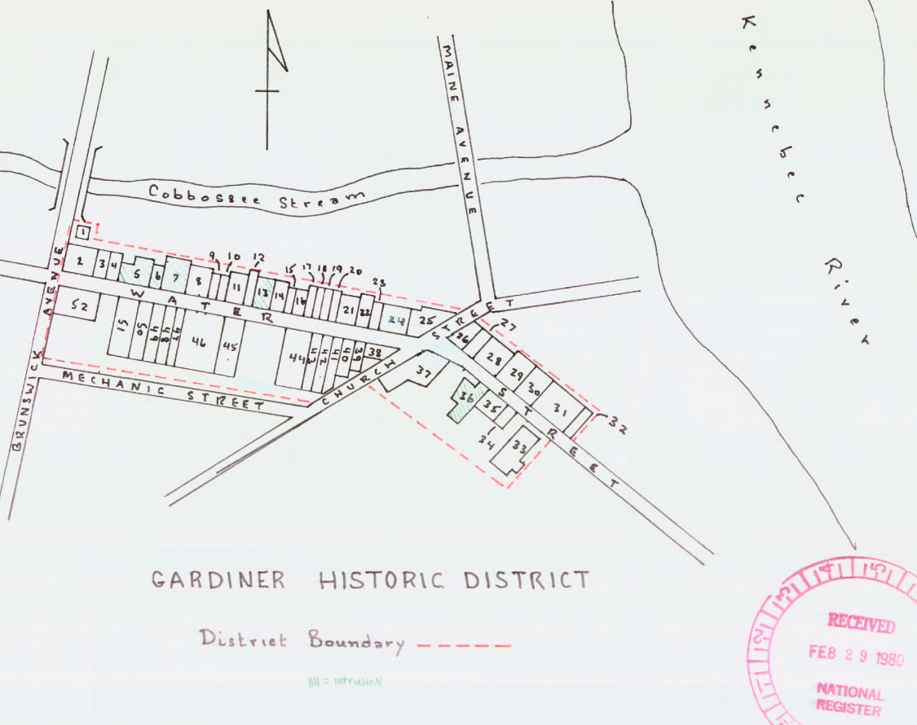

**Project Management**

The Project Manager for the City will be Tracey Desjardins, Director of Economic Development and Planning.

Tracey Desjardins, Economic Development Director/Planner

6 Church Street

Gardiner, Maine 04345

(207) 582-4200

[tdesjardins@gardinermaine.com](mailto:tdesjardins@gardinermaine.com)

The City will hold the contract with the Consultant.

**Project Partners**

Gardiner Main Street: https://www.gardinermainstreet.org/

Gardiner Library Association: https://www.gpl.lib.me.us/support/

Kennebec Valley Council of Governments: https://www.kvcog.org/

**Steering Committee**

To facilitate a successful project, a Downtown Master Plan Steering Committee will be established

to help guide City staff and the Consultant as the project progresses.

The principal role of the Steering Committee will be to act as a bridge between local stakeholders and the Consultant, City, and Partners. The Steering Committee will advise the Consultant City, and Partners regarding the project’s mission, direction, refinement and focus, and future efforts as the project progresses. The Steering Committee will also ensure that the legitimate public concerns, recommendations, and ideas properly inform the project throughout project’s lifespan.

**Scope of Services**

The Consultant will conduct the following minimum tasks. The City strongly encourages

bidders to expand upon these tasks, to provide detail on how they are to be accomplished, to

recommend which tasks require greater emphasis, and to suggest additional tasks that may be

necessary or beneficial but were not identified in this RFP.

**Task 1 – Kickoff Meeting –** The Consultant will work closely with the City, Partners, and Steering Committee to host a public kickoff meeting to generate early excitement for the project.

**Task 2 – Steering Committee Meetings –** The Consultant will participate in monthly steering committee meetings. These meetings, facilitated by the City, will allow for review of plan materials, plan progress updates and direction, and future planning discussion. Ability to attend remotely is an option.

**Task 3 – Public Input –** The Consultant will support the City, Partners, and Steering Committee in public outreach efforts, which will include a survey, visioning session, and draft plan presentation.

**Task 4 – Produce Plan** – The Consultant will produce a Downtown Master Plan that will include the following elements while also maintaining a connection to the Coastal Community Grant program’s goals.

* **Baseline Analysis**: The Consultant shall perform a baseline analysis including, but not limited to, development trends, local and regional demographics, housing and employment characteristics, and economic trends. In short, this analysis will provide a detailed profile of the downtown area.
* **Market Analysis & Economic Vibrancy –** The consultant will provide a market analysis of the downtown retail and housing sectors and make recommendations about business and real estate retention and recruitment to fill identified needs to improve overall market conditions downtown.
* **Land Use Analysis & Recommendations –** The Consultant shall analyze existing and desired Downtown land uses and make recommendations related to those uses. Desired land uses will be determined through the project development process. This analysis shall include open/green space planning
* **Municipal Infrastructure Analysis & Recommendations –** The Consultant shall conduct an analysis of existing and expressed needs for municipal infrastructure improvements including, but not limited to, the following: transportation networks, accessibility, streetscape improvements, lighting, parking, open and public spaces, etc.
* **Illustrative and Conceptual Plans –** The Consultant shall provide conceptual plans that include high quality illustrative design to support the project’s analysis and concepts.
* **Project Schedule and Approach** – The Consultant must include a detailed summary of the project’s approach.
* **Downtown Master Plan Implementation** – The Consultant shall identify appropriate strategies to achieve successful implementation of the Downtown Master Plan. For instance, the implementation plan may include: Federal, State, and local tools required to reach goals, implementation costs, property acquisition costs, land use regulation modifications, capital structure and funding opportunities, zoning amendment recommendations, downtown organization and management recommendations, and strategies for measuring progress of the Downtown Master Plan goals and actions.

**Task 5 – Products –** The Consultant shall prepare a reproducible report of the Downtown Master Plan. The Consultant shall provide the City with ten (10) high quality hard copies of the Downtown Master Plan (and any applicable appendices) and shall also provide the Plan (and any applicable appendices) in PDF format.

**Additional Work Items (as required):**

Services requested of the Consultant beyond the Scope of Services presented in this Request for

Proposals shall be negotiated on an as-needed basis based on hourly rates, by personnel, to be

provided with the Consultant’s proposal.

**Project Schedule**

It is expected that the project shall be completed within ten (10) months of Contract Award. The overall project schedule is (Consultant requirements highlighted):

|  |  |  |  |  |  |  |  |  |  |  |  |  |
| --- | --- | --- | --- | --- | --- | --- | --- | --- | --- | --- | --- | --- |
| Task | 2020 | | | | 2021 | | | | | | | |
| S | O | N | D | J | F | M | A | M | J | J | A |
| **Task**: *Prepare RFP* |  |  |  |  |  |  |  |  |  |  |  |  |
| **Task**: *Form Steering Committee* |  |  |  |  |  |  |  |  |  |  |  |  |
| **Task**: *Consultant Selection and Contract* |  |  |  |  |  |  |  |  |  |  |  |  |
| **Task**: *Kickoff Meeting* |  |  |  |  |  |  |  |  |  |  |  |  |
| **Task**: *Steering Committee Meetings (monthly)* |  |  |  |  |  |  |  |  |  |  |  |  |
| **Task**: *Public Outreach: Survey* |  |  |  |  |  |  |  |  |  |  |  |  |
| **Task**: *Public Outreach: Vision Session* |  |  |  |  |  |  |  |  |  |  |  |  |
| **Task**: *Public Outreach: Draft Plan Presentation* |  |  |  |  |  |  |  |  |  |  |  |  |
| **Task**: *Create Plan and Present to City Council* |  |  |  |  |  |  |  |  |  |  |  |  |
| **Task**: Project wrap-up and reporting |  |  |  |  |  |  |  |  |  |  |  |  |

**Submission Requirements**

All respondents are required to include the following information in the submittal as a minimum.

**1. Project Understanding**: Provide a brief summary of your understanding of the project and the plan area.

**2. Approach**: Describe your recommended approach to achieve each of the tasks outlined in the Services Sought and Scope of Services sections above. Responses are encouraged to think beyond the outlined Scope of Services and provide innovative and cost effective ideas to create a successful plan.

**3. Deliverables**: Provide a description or examples of how you will present the deliverables and the tools that will be used to create project products.

**4. Team Profile**: Provide relevant information regarding the team you propose to work on this project including:

* Overview of firm(s)
* Examples of similar projects with location and reference contacts
* People (experience, availability, commitment)
* Proposed team organization (org chart) of key personnel with titles and specific tasks

**5. Schedule**: Provide a project schedule showing key milestones, deliverable dates, proposed meeting dates for Working Group meetings, stakeholder meetings and public outreach activities, presentations to various boards and commissions and City Council.

**6. Budget**: Provide a proposed budget for the project that details by task line-item the number of hours planned to include assigned personnel and hourly billing rates by discipline. The proposal should also itemize all anticipated sub-consultants. The budget should clearly itemize time required for meetings and project management.

It is expected that this project will be a collaborative effort with the City. City staff will be working closely with the successful respondent on all aspects of the project and in some cases leading elements of the project. Within your response, please include how you would work with City staff to conduct the project in an effort to save costs wherever possible.

A maximum number of thirty (30) pages are allowed for this proposal (not including resumes and samples of work).

**Modification of Proposals**

Modifications to proposals received prior to the submission deadline will be accepted. All modifications must be emailed to Tracey Desjardins and the subject line must read: “MODIFICATION TO PROPOSAL – CITY OF GARDINER DOWNTOWN MASTER PLAN”. Modifications shall include insertion pages or replacement pages and a transmittal letter explaining and indexing the modifications.

**Selection Process**

Upon release of this RFP, the City and Project Partners will be responsible for the review of project proposals and the selection of a qualified project Consultant. All proposals will be opened after the deadline for submitting proposals, in the presence of one or more witnesses, and a register of all applications will be prepared. The proposal opening will not be public. At the discretion of the City and Project Partners, finalists may be interviewed as part of the evaluation process.

**Evaluation Criteria**

Professional firms will be evaluated on the following criteria. These criteria will be the basis for review of the written proposals and optional interview session.

**1. Scope of Proposal**

Does the proposal show an understanding of the project objective, methodology to be used and results that are desired from the project?

**2. Assigned Personnel**

Do the persons who will be working on the project have the necessary skills? Are sufficient people of the requisite skills assigned to the project?

**3. Availability**

Can the work be completed in the necessary time? Can the target start and completion dates be met? Are other qualified personnel available to assist in meeting the project schedule if required? Is the project team available to attend meetings as required by the Scope of Services?

**4. Sustainability**

Does the firm demonstrate a commitment to sustainability in their project proposal? Does the project proposal demonstrate a commitment to the Coastal Community Grant program’s priority goals?

**5. Cost and Work Hours**

Do the proposed cost and work hours compare favorably with the project manager's estimate? Are the work hours presented reasonable for the effort required in each project task or phase?

**6. Firm Capability**

Does the firm have the support capabilities the assigned personnel require? Has the firm done previous projects of this type and scope?

**Conditions of Submission**

All proposals submitted in response to this RFP become the property of the City. The City has the right to disclose information contained in the proposals after an award has been made unless Consultant requests certain portions remain confidential. All products developed for this project shall be considered public information and shall be co-owned by the City and the Consultant.

The City reserves the right to reject or modify any and all proposals submitted for consideration and to negotiate with any and all responders. The City reserves the right to amend the RFP and bidders are encouraged to regularly check the City’s website for updates.

**Selection Schedule**

October ­­2, 2020: Release of RFP

October 16, 2020: Last day to submit written questions on RFP*

October 30, 2020, 12:00 p.m: Deadline for submission of proposals

Week of November 9, 2020: Web based interviews (if necessary) with selected consultant candidates

November 18, 2020: Present recommendation to Council for approval. Approximate date of award announcement

November 19, 2020: Approximate start date for consultant

All questions related to the interpretation of this Request for Proposals must be submitted by email to the Tracey Desjardins. Questions will be answered Wednesday, October 21, 2020 and will be posted to the City’s website.

**Submissions of Proposal**

Submissions shall be emailed to Tracey Desjardins at the following address: [tdesjardins@gardinermaine.com](mailto:tdesjardins@gardinermaine.com). One (1) electronic copy of the proposal must be received by 12:00 p.m. EST, October 30. The email subject line must read “CITY OF GARDINER DOWNTOWN MASTER PLAN”.